Applying Advanced Protocols: IPSec & DNSSEC Implementation

Student’s Name

Institutional Affiliation
Date
IPSec & DNSSEC Implementation
Initially, the IP Security Protocol (IPsec) was developed with the intention of guaranteeing security in the N layer of the OSI model (network layer) in an insecure network (Binkley, 2016). Even with the initial focus on sending IP packets, it allows the system to manage security protocols, modes of operation and secret keys that are used in network services. The purpose of IPsec is to provide privacy for the user, data integrity and information authenticity, when information is transferred over IP networks over the internet (Fetzer, & Jim, 2017). The use of IPsec in conjunction with L2TP is considered to be one of the most suitable options for creating VPN connections (Binkley, 2016). The main security protocols used in the requested services, such as basic authentication, data integrity and encryption, are: header authentication (Authentication Header, AH) and encapsulation for message security (Encapsulated Security Payload, ESP).
IPsec, by default, uses IKE for authentication and to determine protocols, keys and algorithms, making it useful for: large regions, highly scalable networks and VPN network implementations (Fetzer, & Jim, 2017). The IKE types of IPsec can be divided into two types: automatic and manual. To guarantee the use of digital certification, a tunnel, authenticated and secure, is created in order to exchange keys and establish a safe association (Security Association, SA). SA can be understood as: parameters that control identifier algorithms, modes of operation and keys (Le, & Guyennet, 2016). Such parameters regulate mechanisms to protect information traffic. The definition of the key generation mode, authentication, creation and management of the SA is done using the Internet Security Association and Key Management Protocol (ISAKMP).
Unlike automatic management, in the manual, SA switches and parameters are manually configured on both sides, before VPN communication begins. Only the sender and recipient of the communication know the secret key, which is used (Binkley, 2016). If the data authentication is validated, the recipient guarantees that the information came from the issuer and has not been modified, however if one of the keys is obtained by third parties, these can be passed on by the user (Cowperthwaite, & Somayaji, 2016). Thus, manual management is recommended for small locations with a number of static connection points, and is not recommended for scalable networks.
Domain Name System Security Extensions (DNSSEC) is a standard that adds security extensions to DNS by protecting and authenticating DNS traffic through asymmetric digital signatures (Binkley, 2016). DNSSEC solves some problems found in current DNS technology. Bogus DNS data makes chances to take data from outsiders or change information in different kinds of exchanges, for example, electronic buys (Binkley, 2016). In DNS innovation, a DNS assault with fashioned data is very hard to identify and by and by difficult to forestall. The purpose of the DNSSEC extension is to secure the DNS content and prevent these attacks by validating the data and ensuring the source of the information (Cowperthwaite, & Somayaji, 2016).
Given the relevance of DNSSEC, PTServidor created a study and development group that divided its implementation into three phases (Cowperthwaite, & Somayaji, 2016). In a first phase, the changes to be produced in the PTServidor services platform were analyzed, resulting in tests on a parallel infrastructure and having led to the successful implementation of this security protocol in .PT domains in a production environment and together with some more visionary customers (Binkley, 2016). In a second phase, PTServidor started the implementation of DNSSEC in existing .PT domains in dedicated services of its customers who have expressed interest in seeing their domains signed by this protocol (Le, & Guyennet, 2016).

References
Binkley, J. (2016). An integrated IPSEC and mobile-IP for freeBSD. Technical Report, International Symposium on Cluster Computing and the Grid, 1-10.
Cowperthwaite, A., & Somayaji, A. (2016). The futility of DNSSec. In Annual Symposium Information Assurance (ASIA), 6-13.
Fetzer, C., & Jim, T. (2017). Incentives and Disincentives for DNSSEC Deployment. Incentives and Disincentives for DNSSEC Deployment, 12-34.
Le, V., & Guyennet, H. (2016). IPSec and DNSSEC to support GRID application security. In 2nd IEEE/ACM International Symposium on Cluster Computing and the Grid (CCGRID'02) (pp. 4-18). IEEE.
DNSSEC Implementation
Figure 1:
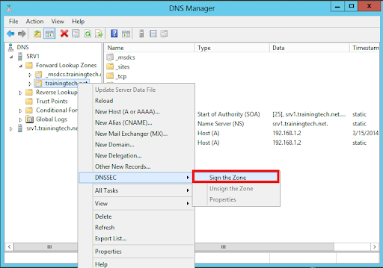

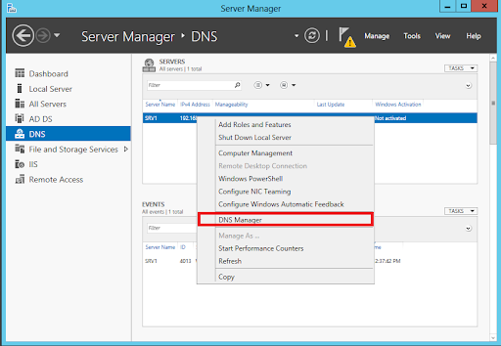
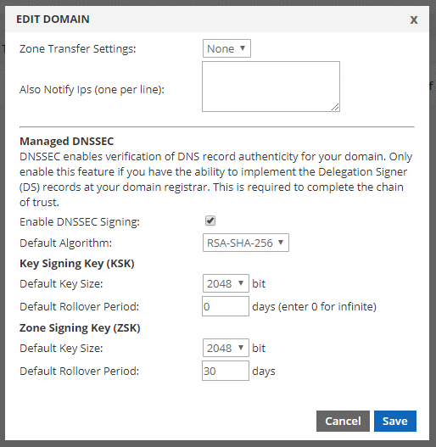

IPSec & Implementation
Figure 2:
